Automatic Player Face Detection and Recognition for Players in Cricket Games

In this paper author employing combination of Linear Discriminant Analysis (LDA) and ADABOOST algorithm to detect and recognize cricket player faces. LDA will be used to extract features from the faces and then extracted features will be trained with ADABOOST algorithm to player recognition.

To detect face region author has used Viola Jones OPENCV algorithm and then detected faces will be feed to LDA and ADABOOST algorithm for further recognition. Faces trained with LDA and ADABOOST giving more accuracy compare to existing CNN and FRCNN algorithms.

To train algorithms author has generated his own dataset with different by capturing player images from different scenes such as occlusion (some hidden faces with helmet or shades), non-uniform illumination (with or without light), expression and pose variation. Author has not published generated dataset so we have used some player images downloaded from GOOGLE.

Extension Concept

To further enhance accuracy we have experimented with various pre-trained model but VGG19 with enhance CNN layer giving high accuracy compare to propose algorithm. Enhanced VGG19-CNN contains additional layer called Dropout to remove all irrelevant training features and then get trained only on relevant features to gain accuracy.

SCREEN SHOTS

We have coded this project using JUPYTER notebook and below are the code and output screens with blue colour comments

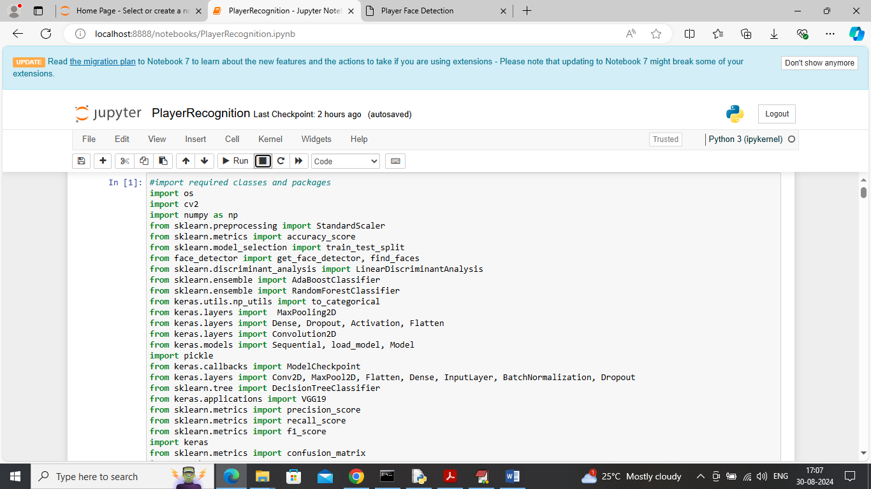

In above screen importing required python classes and packages

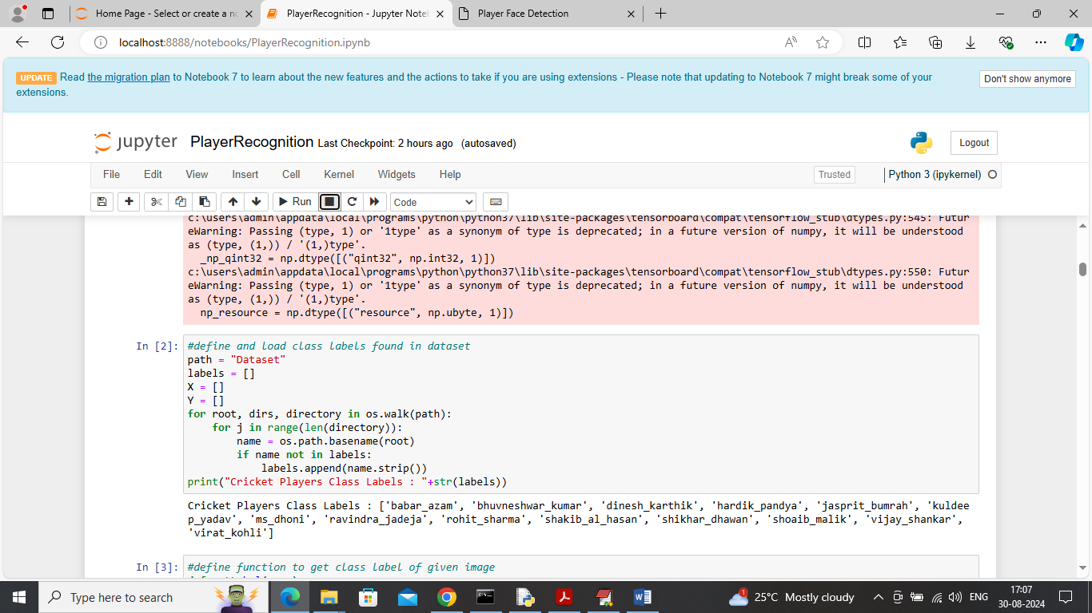

In above screen loading and displaying all player names available in dataset

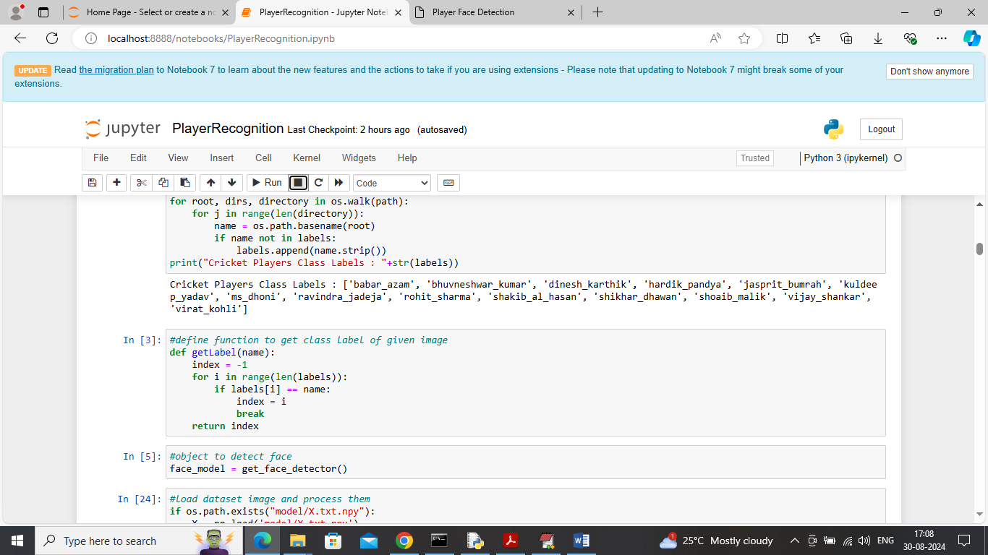

In above screen initializing face detection model

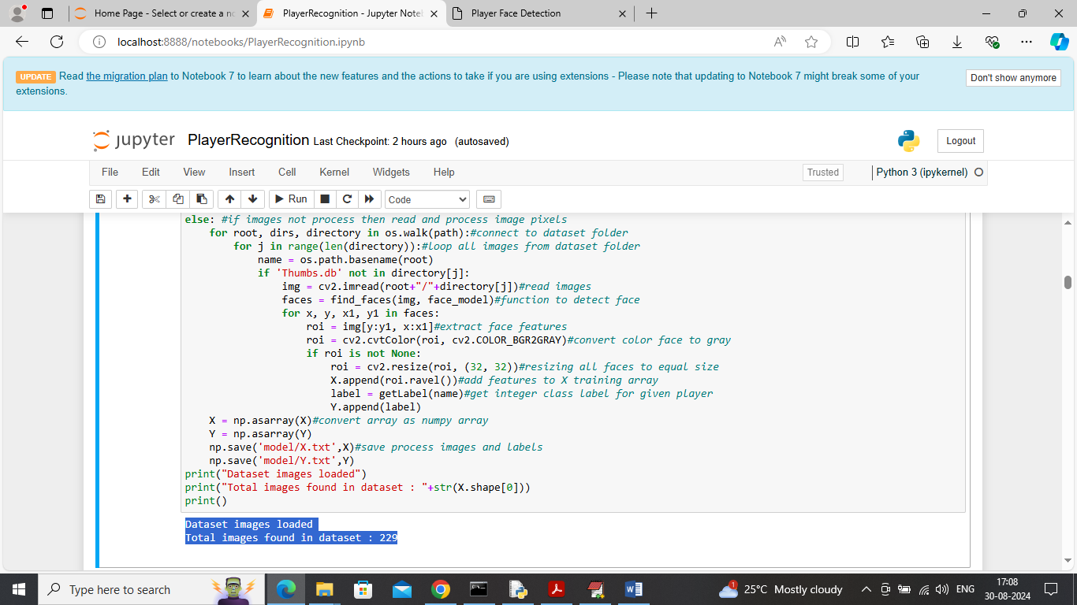

In above screen looping and reading all images from dataset and then extracting faces from each image and then adding to X and Y training array

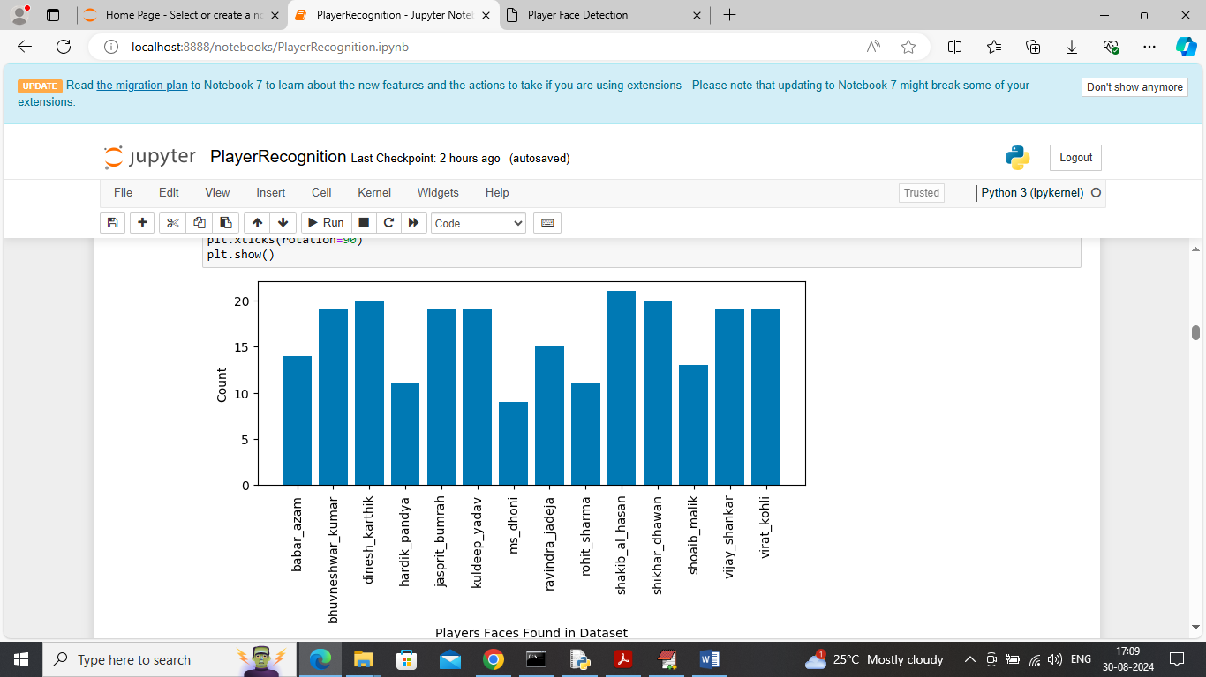

In above screen visualizing graph of different players exists in dataset where x-axis represents player names and y-axis represents number of images

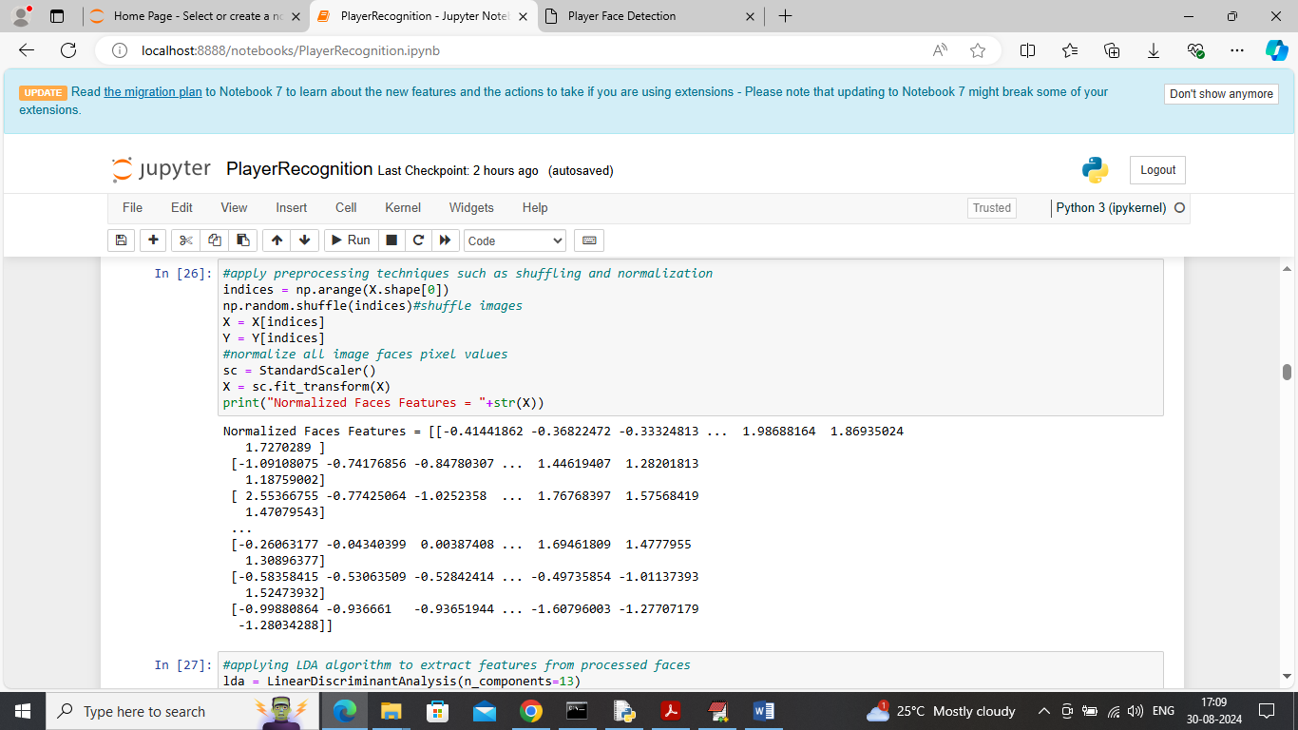

In above screen applying various processing techniques such as shuffling and normalization

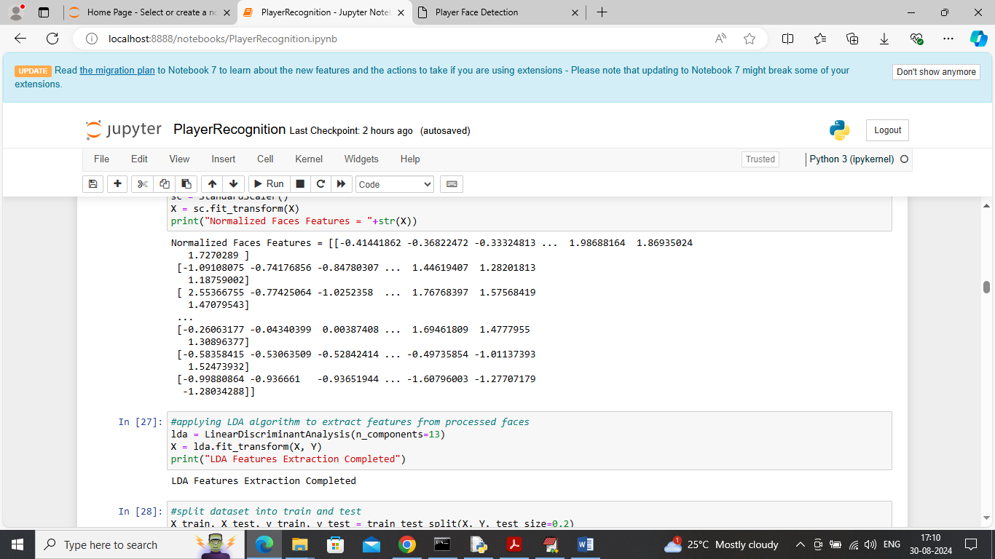

In above screen applying LDA algorithm to extract features from all processed images

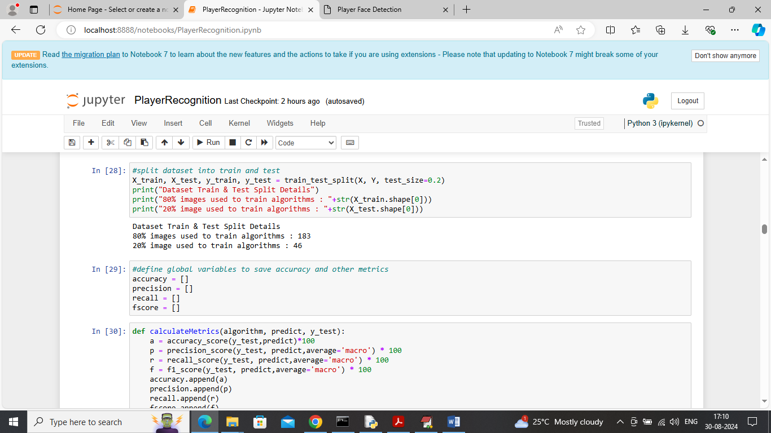

In above screen splitting processed features into train and test and then defining function to calculate accuracy and other metrics

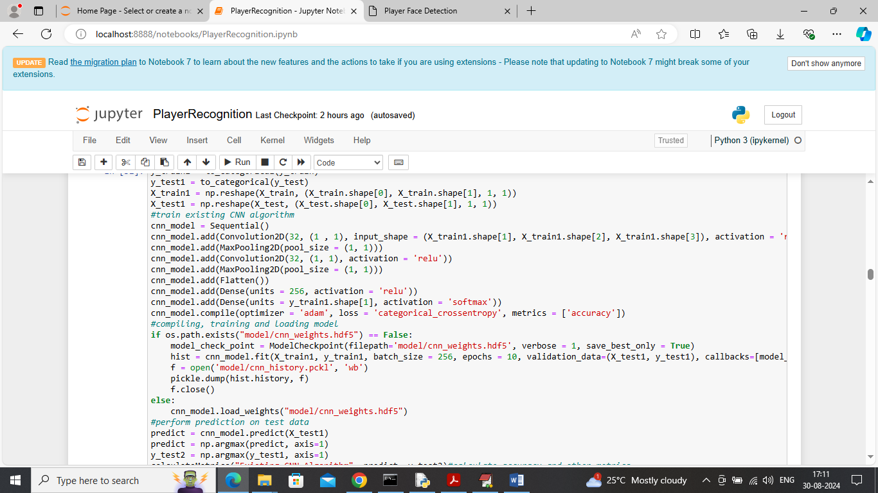

In above screen training existing CNN algorithm and after training above algorithm will get below output

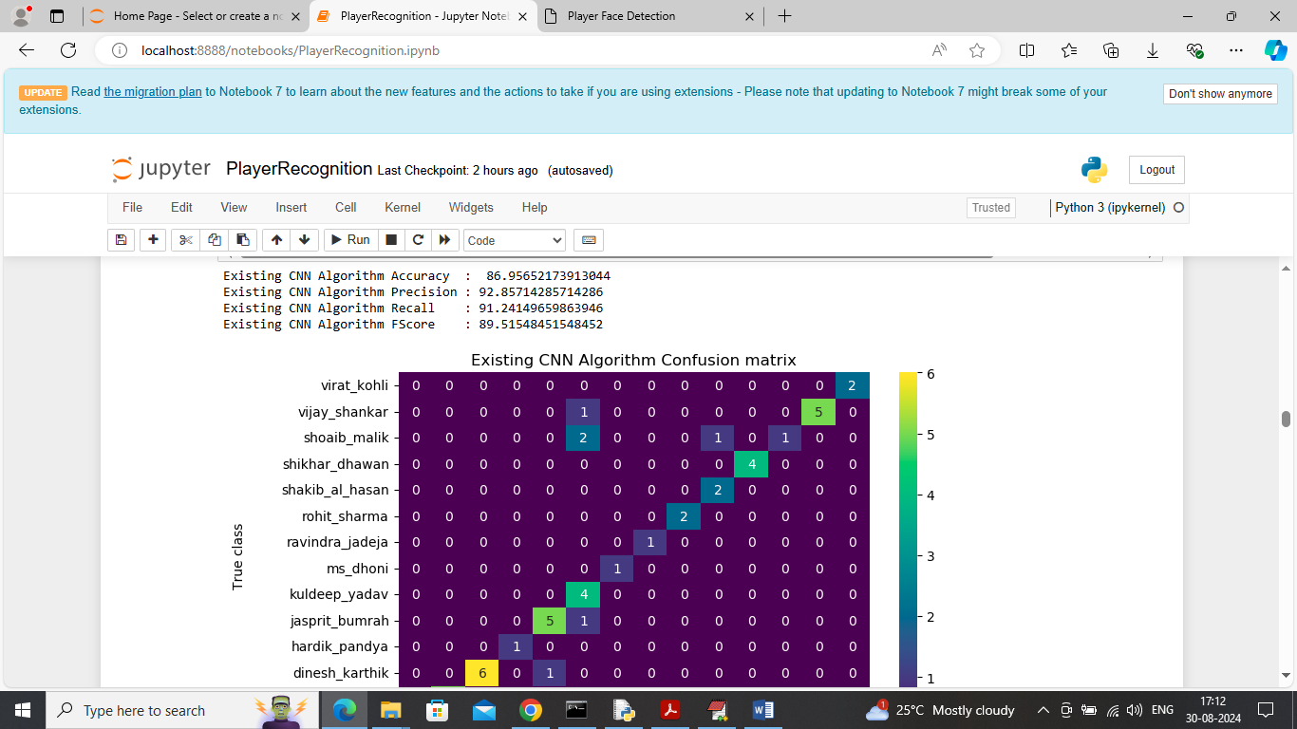

In above screen existing CNN algorithm got 86% accuracy and can see other metrics like precision, recall and FSCORE. In above confusion matrix graph x-axis represents Predicted Player names and y-axis represents True Player names and then all different colour boxes in diagnol represents correct prediction count and remaining all blue boxes represents incorrect prediction count

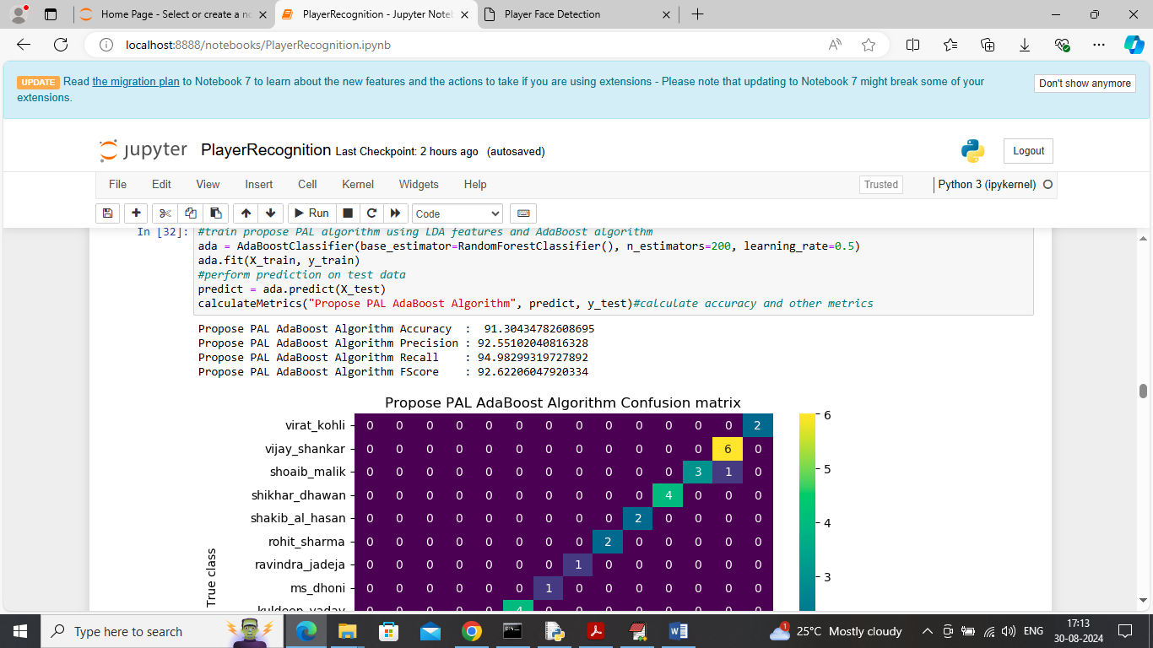

In above screen training propose PAL ADABOOST algorithm with LDA features and then propose algorithm got 91% accuracy and can see other metrics along with confusion matrix graph

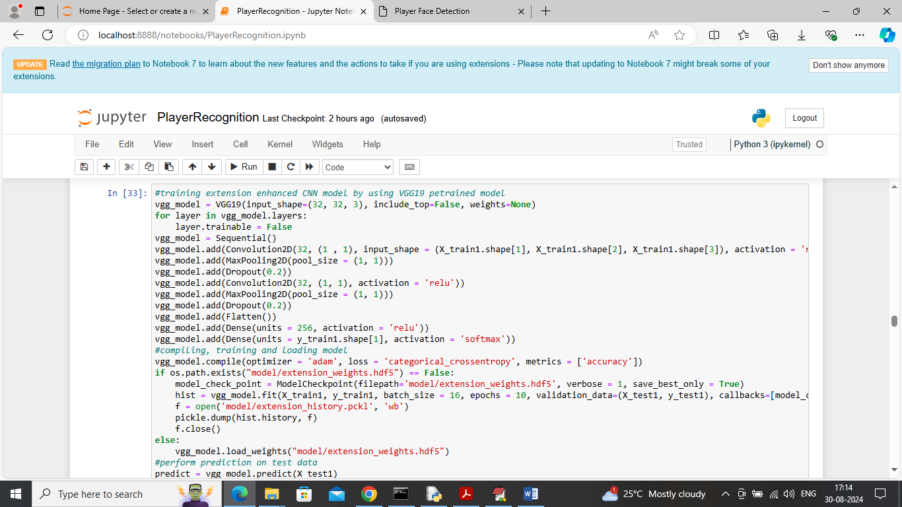

In above screen training pre-trained VGG19 enhanced CNN model and after executing above block will get below output

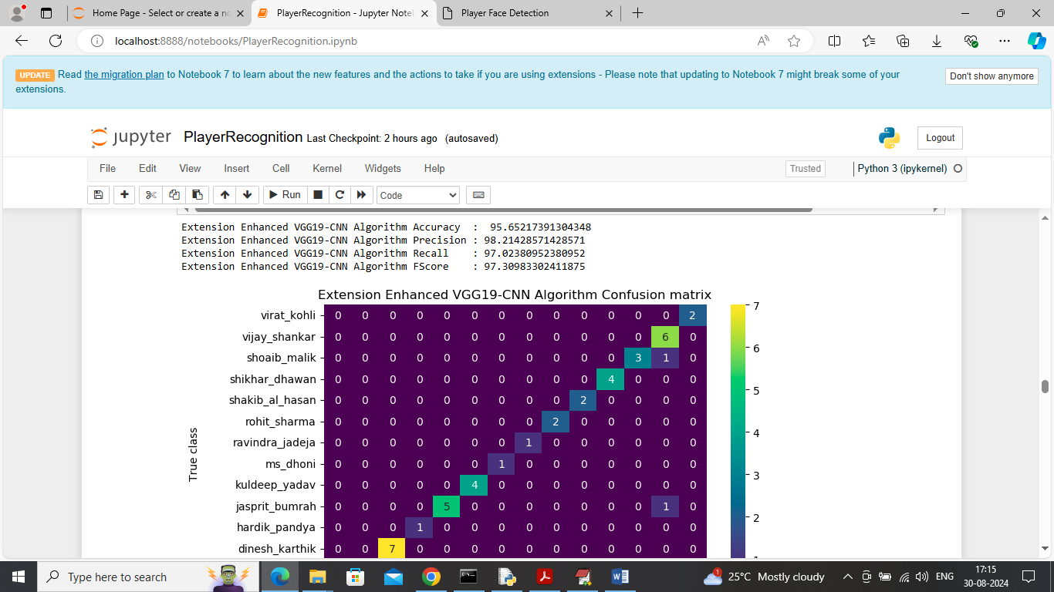

In above screen extension VGG19-CNN model got 95% accuracy and can see other metrics also

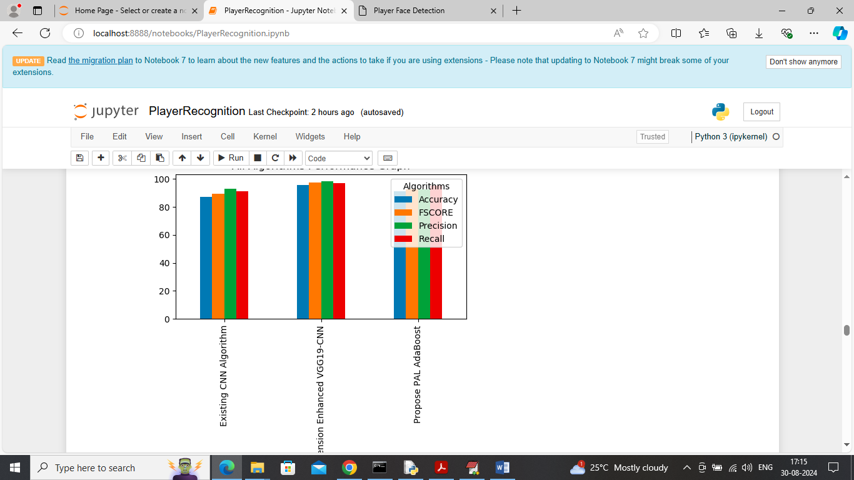

In above screen displaying all algorithms performance graph where x-axis represents algorithm names and y-axis represents accuracy and other metrics in different colour bars

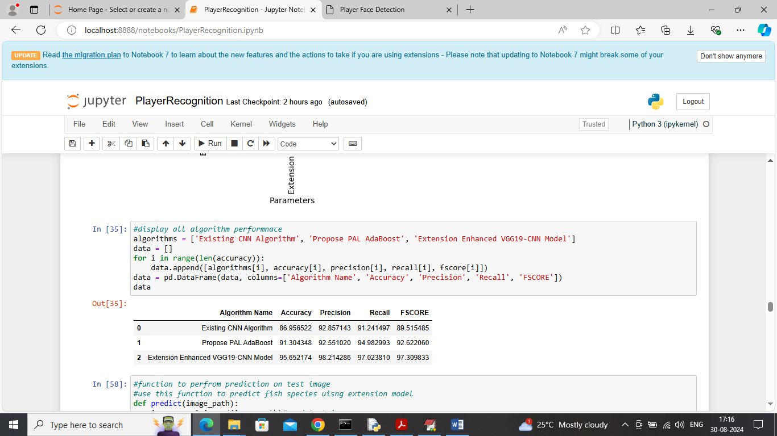

In above screen displaying all algorithms performance in tabular format

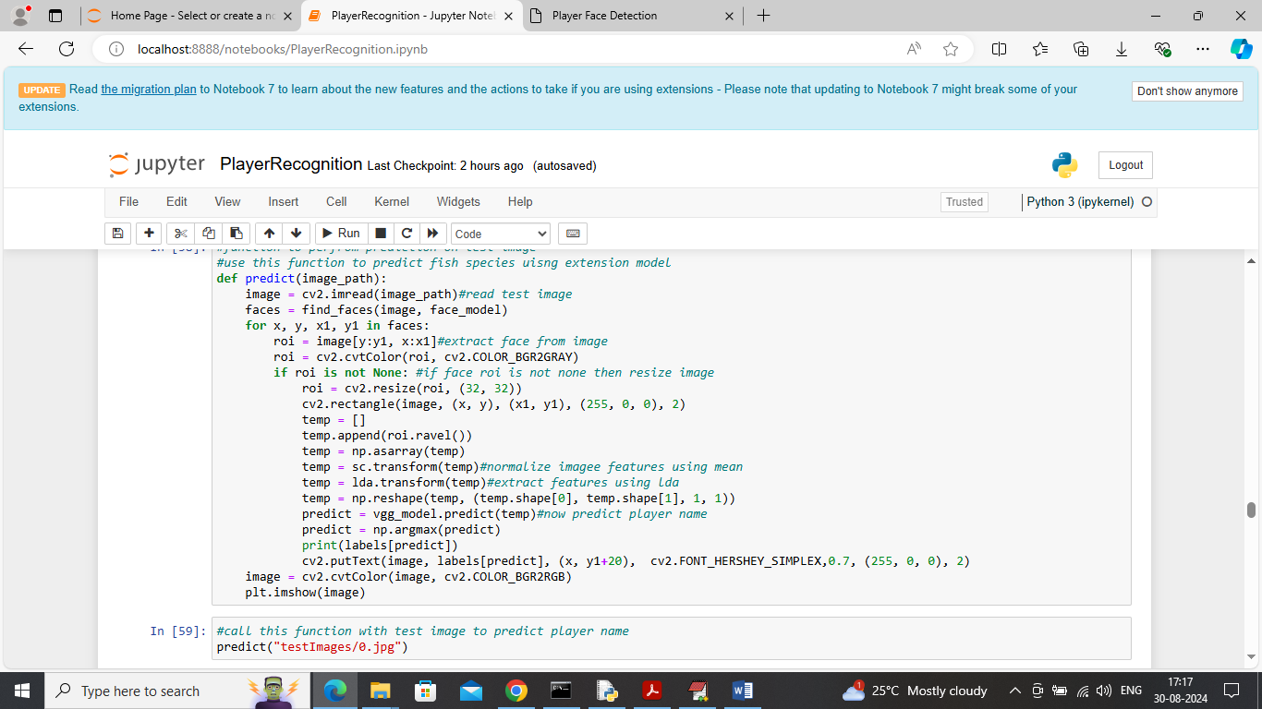

In above screen defining predict function which will read image, extract face, normalize face, apply LDA and extension VGG19-CNN model to detect and recognize player

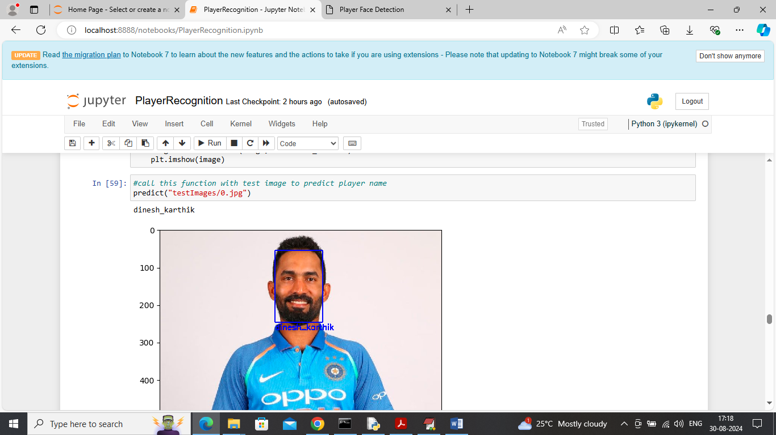

In above screen called test image with predict function and then player recognized as ‘Dinesh Kartik’

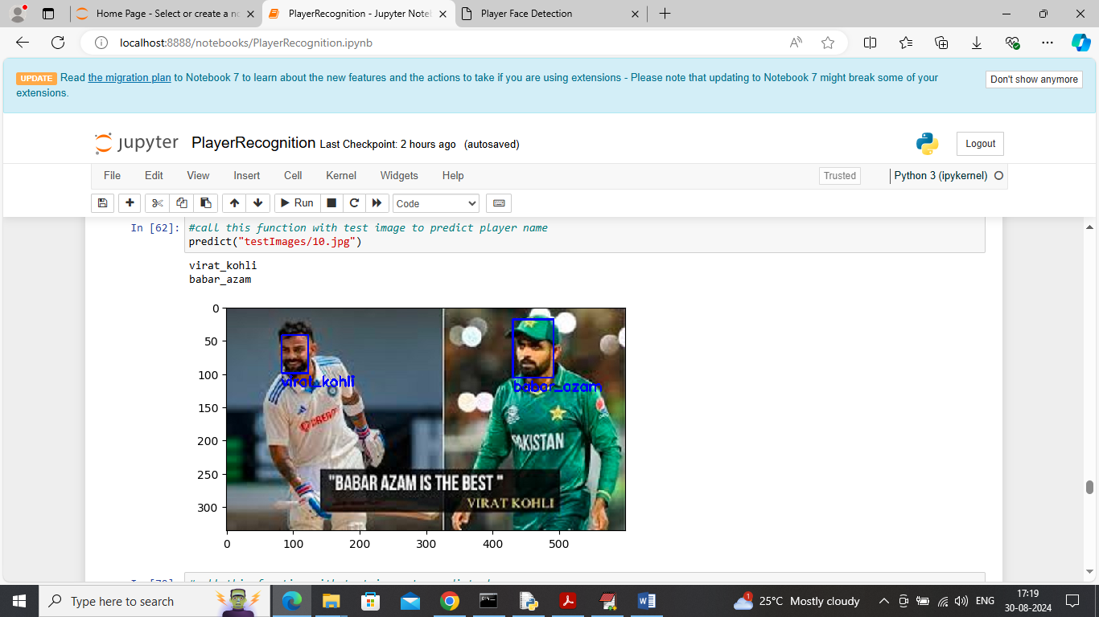

In above screen kohli and azam player recognized which can see in blue colour text

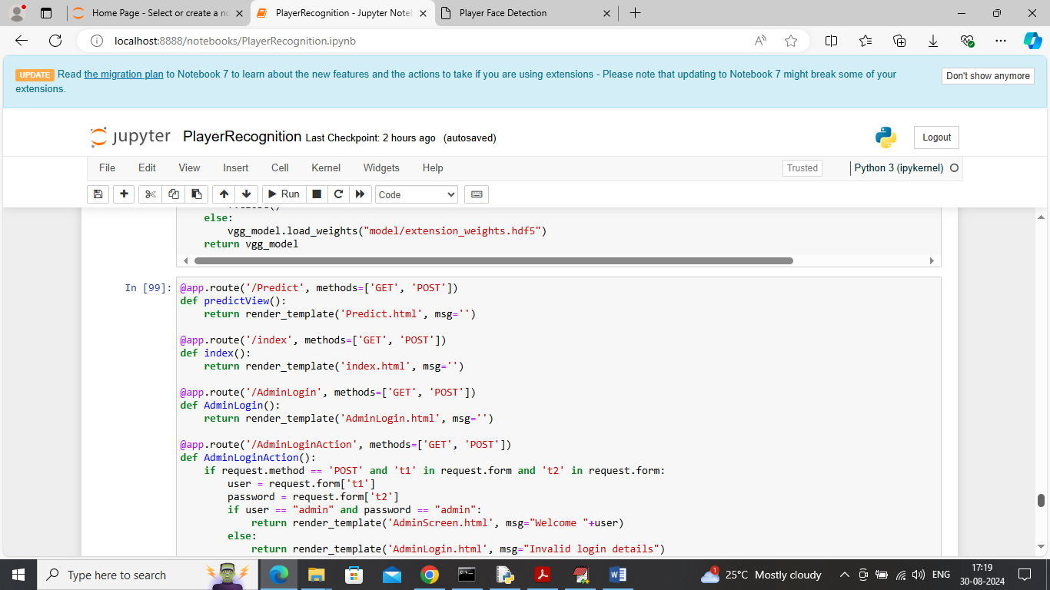

In above screen defining flask code and after executing above block will get below output

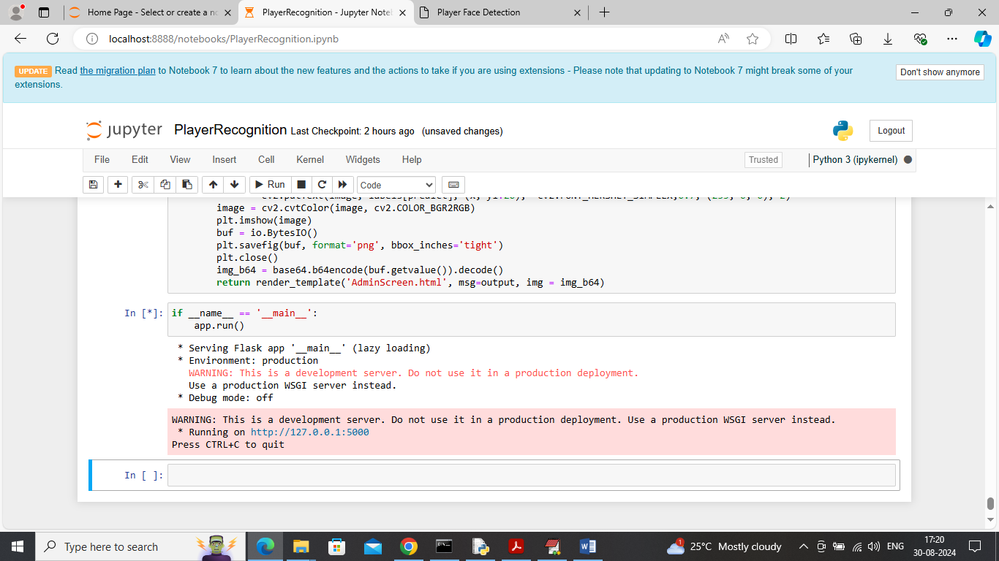

In above screen flask server started and now open browser and enter URL as <http://127.0.0.1:5000/index> and press enter key to get below page

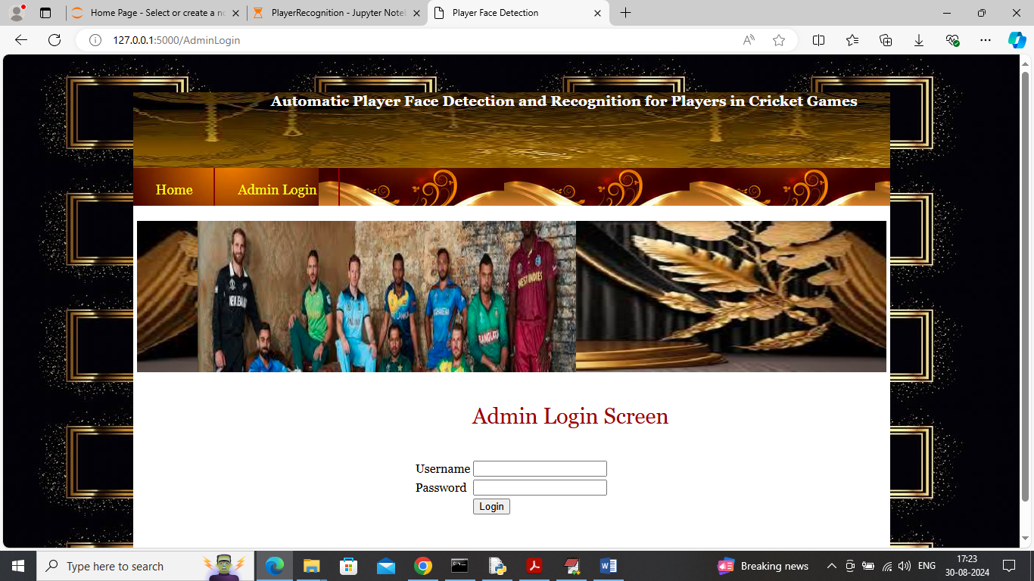

In above screen click on ‘Admin Login’ link to get below page

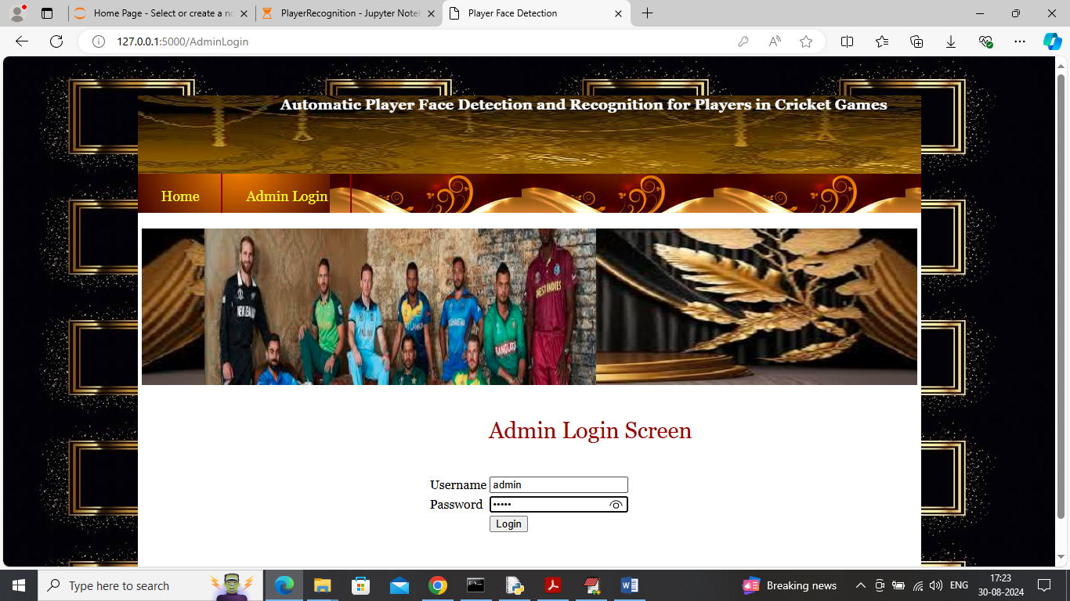

In above screen admin is login and after login will get below page

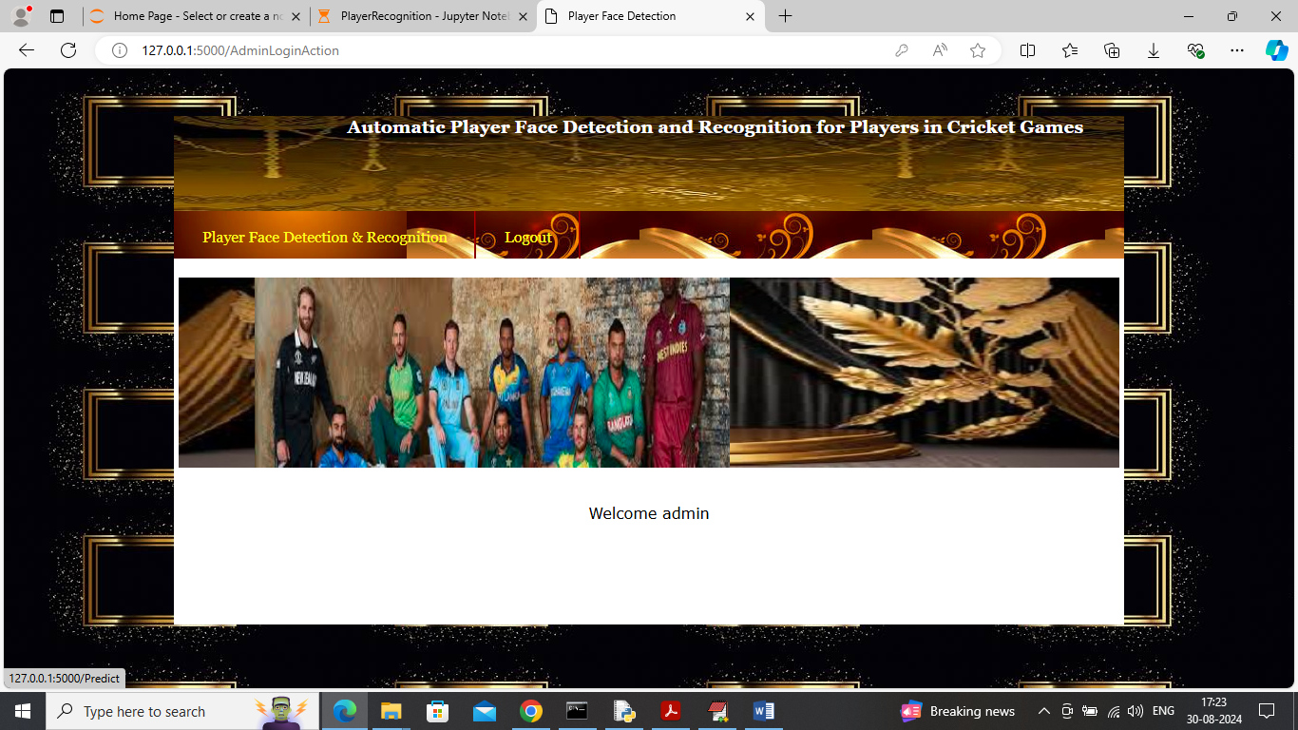

In above screen click on ‘Player Face Detection & Recognition’ link to get below page

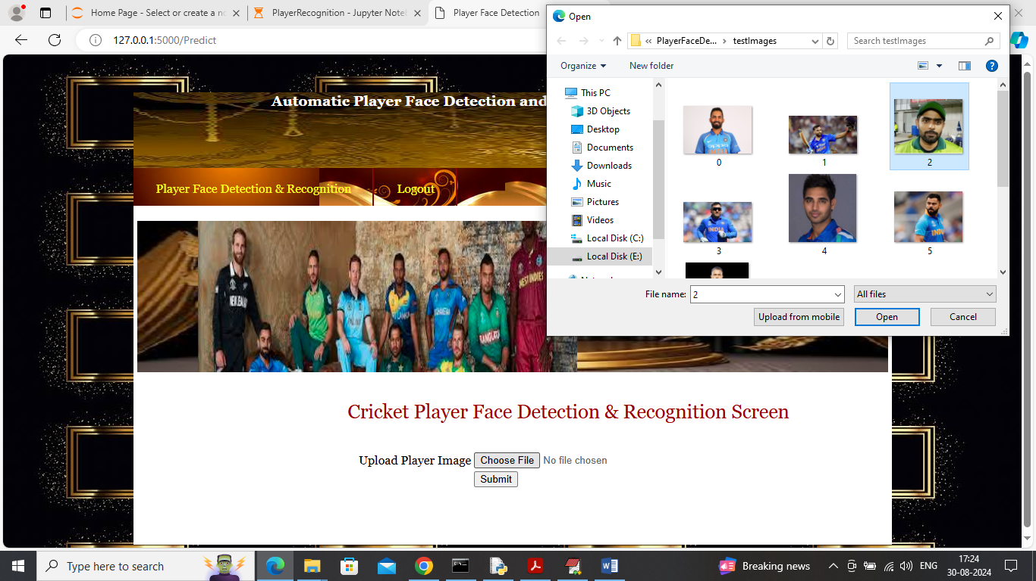

In above screen uploading image and then click on ‘Open’ and ‘Submit’ button to get below page

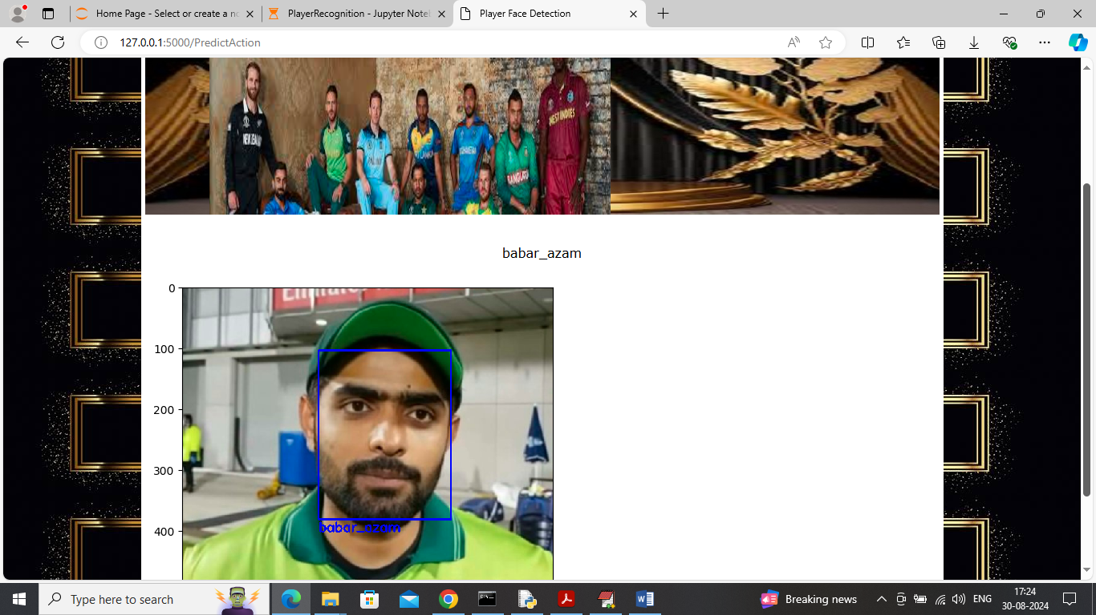

In above screen detected and recognized player name

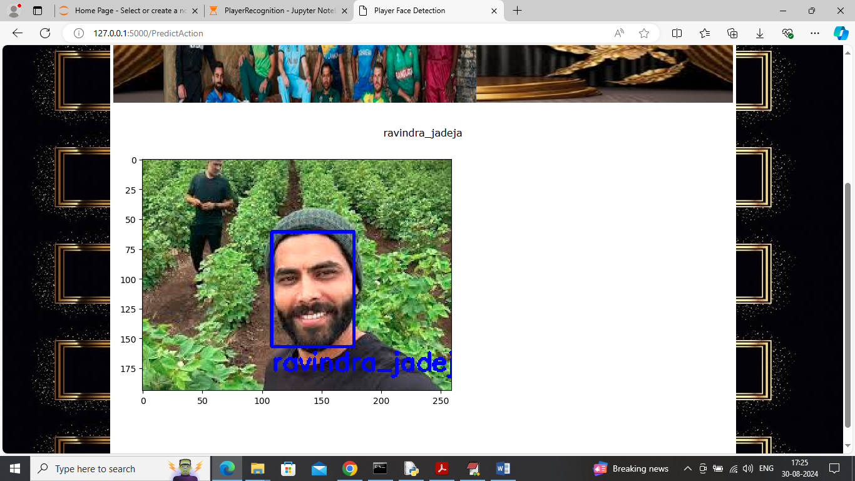

In above screen can see another play example output and similarly you can upload and test other images